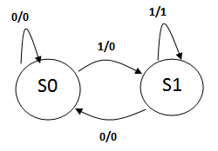

**Two consecutive 1s (11) sequence or pattern detector using Mealy FSM with two states. Here overlapping patterns are also detected.**

**module fsm_two1s_mealy3 (x, rst, clk, z);**

**input x, rst, clk;**

**output z; reg z;**

**parameter S0 = 0, S1 = 1;**

**reg PS, NS;**

**always @ (posedge clk, rst)**

**if (rst)**

**PS <= S0;**

**else**

**PS <= NS;**

**always @ (PS or x)**

**case (PS)**

**S0: begin**

**z = x? 0:0;**

**NS = x? S1:S0;**

**end**

**S1: begin**

**z = x? 1:0;**

**NS = x? S1:S0;**

**end**

**endcase**

**endmodule**

**module tst_fsm_mealy;**

**reg x, rst, clk;**

**wire z;**

**fsm_two1s_mealy3 fm (x, rst, clk, z);**

**initial begin**

**clk = 0;**

**x = 0;**

**#10 x = 1;**

**#20 x = 0;**

**#20 x = 1;**

**#20 x = 1;**

**#20 x = 1;**

**end**

**initial begin**

**rst = 1;**

**#10 rst = 0;**

**end**

**always**

**#10 clk = ~clk;**

**endmodule**

